- Install Virtualbox/VMware Workstation with different flavours of linux or windows OS on top of your present windows environment.

AIM
To install and configure Oracle VM VirtualBox on a Windows host and create a virtual machine with a Linux/Windows operating system running on top of the existing Windows environment.
PROCEDURE
- Install Oracle VM VirtualBox on the Windows computer.
- Download the required operating-system ISO file, such as Ubuntu Linux or Windows. VirtualBox requires an OS installation image such as an ISO.
- Oracle Documentation
- Open Oracle VM VirtualBox Manager.
- Click New to create a virtual machine.
- Oracle Documentation
- Enter a name for the VM, for example:
- Ubuntu VM
- Windows VM
- Select the appropriate OS Type and Version.
- Select the downloaded ISO Image.
- Allocate RAM and CPU resources to the virtual machine.
- Create a virtual hard disk and specify its storage size.
- Click Finish to create the VM.
- Select the VM and click Start.
- The VM boots from the selected ISO and starts the operating-system installation.
- Oracle Documentation
- Follow the OS installation instructions and create the required username and password.
- After installation, restart the VM and log in to the installed operating system.
- The guest OS can now be used independently inside the Windows host.

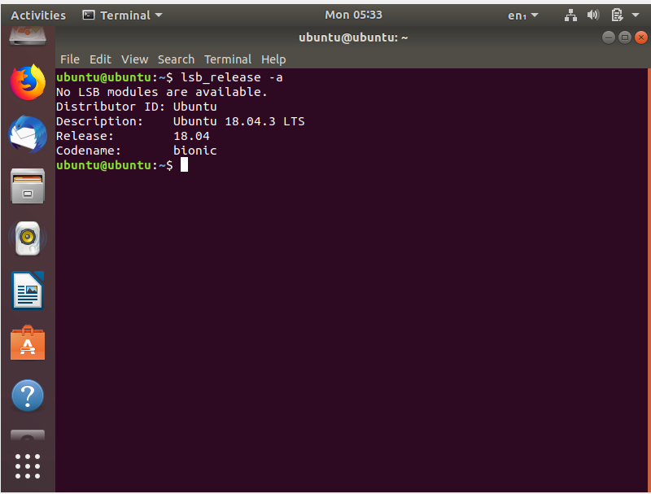
VIRTUALBOX MANAGER
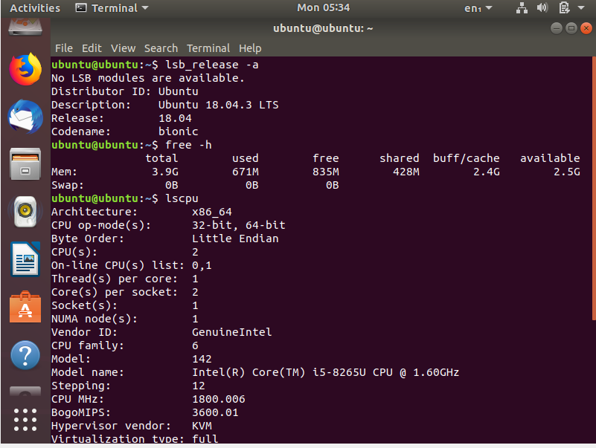

UBUNTU VERSION
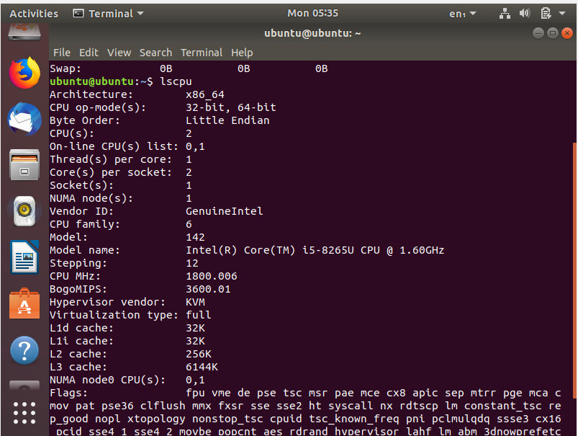

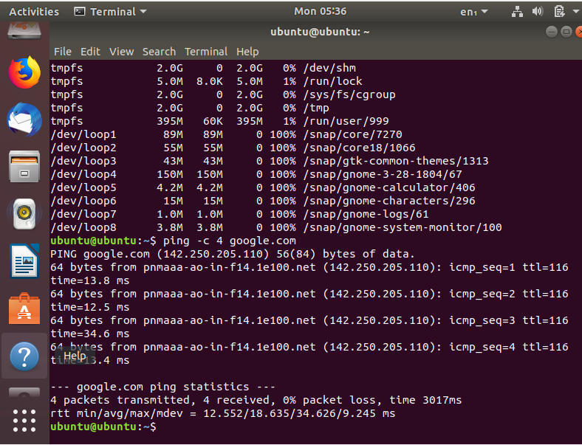
NETWORK TEST
RESULT
The Oracle VM VirtualBox was successfully installed and configured, and a Linux/Windows operating system was successfully installed and executed as a virtual machine on top of the existing Windows environment.

